LOCATION : NATIONWIDE
DATE : 29.12.2017
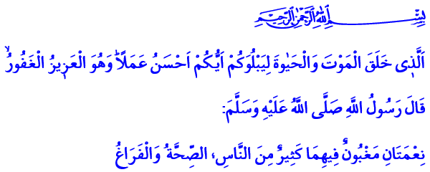
OUR IRREPLACEABLE WEALTH: LIFE
Blessed Friday to You, Honorable Believers!
Our Lord Almighty enjoins in the verse I have recited: “[He] who created death and life to test you [as to] which of you is best in deed - and He is the Exalted in Might, the Forgiving.”
Our Prophet (pbuh) says in the hadith I have read: “There are two blessings which many people lose: (They are) Health and free time for doing good.”
Brothers and Sisters!
We are on the verge of a new year of the Gregorian calendar. We are about to leave behind a year from our irreplaceable wealth: our lives. May our Lord Almighty bless us with a bountiful life. May He make the days ahead of us better than the days we have left behind.
Dear Brothers and Sisters!
Whether we name the years or calculate the days according to Islamic or Gregorian calendars; the one and only master of time is our Lord Almighty. He is the One Who entrusted each moment we have to us as a blessing. And what really matters before our Lord is how we spend our time; for what purpose we spend our limited breaths; whether we use the blessing of life in accordance with the purpose of our creation.
Brothers and Sisters!
We call the short period of time that our Lord deemed fit for us life. Life describes a period that should be made prosperous and transformed into eternal gains. The mortal life on this earth is made prosperous if it is dressed with faith in Allah and righteous deeds. This very short life is made bountiful if it is lived in accordance with Allah’s countenance with a sense of responsibility and trust.
Honorable Brothers and Sisters!
Our Almighty Lord provides opportunities for each one of us for us to make our life more meaningful and bountiful. The beginning of a new year which informs us about how swiftly the time passes is one of those opportunities. This is an opportunity for us to make a fresh start to life, so to speak, and open yet another clean page; to define new resolutions and high ideals, to make good plans for the year ahead. This is an opportunity for us to take account of ourselves, review and correct our mistakes and repent for our sins.
Brothers and Sisters!
Then let us ask ourselves these questions as we leave behind a year from our lives:
How close were we to Allah Almighty, when whole creation in the earth and the sky praised Him? How faithful were we for our oath to Allah we gave after the question 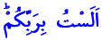 “Am I not your Lord?”? To what extent we were able to heed His orders, or refrain from what He forbidden?
Which righteous deeds, goodness or beautiful things we recorded on our book of good deeds? To what extent we were able to protect our hands, tongue, eyes, ears, mind and heart from unlawful things and sins?
How many of our days did we make more fruitful than the other, in this life where those who live two equal days are losers? How many of our days we were able to turn into eternal gains?
To what extent we were able to fulfill our responsibilities towards our mother and father, wife and children, relatives and neighbors? To what extent we were able to make the suffering of those in need our suffering? What did we do to relive the suffering of our oppressed brothers and sisters, wherever in the world?
Brothers and Sisters!
It is not fitting for us to waste the hours we should answer these questions on some wrong behaviors that have no place in our belief, culture and tradition. To pin our hope upon lottery and games of chance and try to earn money without labor or any effort is incompatible with the sensitivity of our religion on lawful earnings. Wasting our health away with alcoholic drinks, killing our time with unlimited and improper pleasures is absolutely incompatible with the sense of trust that a believer should have.
Because, as the Prophet (pbuh) stated, a believer should appreciate the value of his health before he gets ill. He should spend his free time doing good before he gets busy. He should use his youth on good deeds before old age catches up with him. He should use his wealth and resources as means for his happiness in the hereafter before he loses them.
Brothers and Sisters!
What we ask from our Lord Almighty in this last Friday of the year is that may He grant us the ability to carry this blessing of faith until our last breath. May He make our days, months and years bountiful with good deeds. May He makes us His servants who are good and who make good deeds, who refrain from evil and forbid evil things. May He help us in doing the deeds that would earn us heaven and avoid the actions that would lead us to hell.

Al-Mulk, 67/2.
Al-Bukhari, To Make the Heart Tender (Ar-Riqaq), 1.
Hakim, al-Mustadrak, IV, 341. Written by: General Directorate of Religious Services

